PROFILE OF FACULTY MEMBERS
DR. OTIVE IGBUZOR
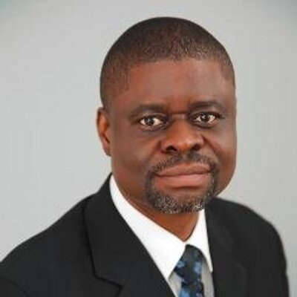
Dr. Otive Igbuzor is Founding Executive Director of the African Centre for Leadership, Strategy and Development (Centre LSD) and currently the Chief of Staff to the Deputy Senate President of the 9th Senate. He is a former international head of campaigns of Action Aid Nigeria. Action Aid International is an International organization working with people’s communities, associates and partners over 50 countries in Africa, Asia, the America and Europe to eradicate poverty and injustice. He was a former commissioner in the police Service Commissioner (PSC) from 2008 to 2013 representing civil society. Prior to joining ActionAid, he was a programmer co-ordinator of Centre for Democracy and Development (CDD), an independent research, information and training institution dedicated policy-oriented scholarship on questions of democratic development and peace building in the West African sub-region. He also served as secretary of Citizens’ Forum for Constitutional Reform (CFCR), a coalition of over one hundred civil society organizations committed to a process led and participatory approach to constitutional reform in Nigeria. Previously, he was lecturer at the Delta State University, Lagos Centre and has published many scholarly articles on democracy, gender, politics and development. He is the author of Perspectives on Democracy and Development Challenges of Development in Nigeria; the co-editor of two authoritative books on Constitution making and constitutionalism in Nigeria: Contentious Issues in the Review of the 1999 Constitution and a citizen’s approach to make a people’s constitution in Nigeria, and two others, one on Poverty Eradication titled Poverty Eradication in Nigeria: Perspectives on a Participatory and pr-poor approach and the other of millennium development Goals (MDGs) titled Can Nigeria achieve the MDGs in 2015? He holds a bachelor’s degree in Pharmacy, master’ degree in Public Administration and International Relations and a doctorate degree in Public Administration specializing in Policy Analysis. He was a founding and leading member of many human rights and mass democratic organizations in Nigeria in the 1980s and ‘90s. He is a member of many professional associations including Pharmaceutical Society of Nigeria (PSN) and Nigerian Institute of Management. He is a fellow of the Nigerian Institute of Strategic Management and President of the Ejiro&OtiveIgbuzor Foundation.

Pst. EDEWOR EGEDEGBE
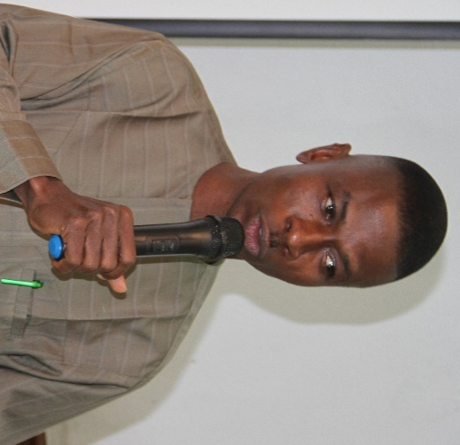
Edewor Egedegbe is a Pastor and Founding Executive Director of the Value Rebirth and Empowerment Initiative (VREI). Director of Studies, Value Rebirth-Centre LSD Leadership School, Effurun-Warri Study Centre. A Minister of the gospel of the Lord Jesus Christ with the Living Faith Church, who believes in going beyond the pulpit to the pew. Served in several capacities including Head of Station, Associate Pastor and at board levels and still serving. He is the National President of Network for Positive Change (NPC) a pressure group that propagates the entrenchment of moral values and mindset change for citizens and societal betterment. A man of many paths, a set four graduate of the Centre LSD Leadership School, Abuja. He holds a Bachelor of Science Degree in Marketing, Abia State University, Uturu, a Bachelor of Science Degree in Criminology and Security Studies in view, National Open University, Managing Director/Chief Executive Officer of the RobbyDee CorporateServices; a strategic development consulting outfit established in 2000, Chairman, Chief Executive Officer, RobbyDee Global Security Ltd, National Secretary, Central Working Committee(CWC) Partners for Peace (P4P) in the Niger Delta, Member - Women, Peace and Security Network (WPS), Member – Delta State Economic Literacy and Budget Accountability for Governance (DELBAG). Deputy Coordinator, Transition Monitoring Group (TMG), Delta State, Convener, Delta State Civil Society Organizations for Good Governance,CO-Chair, Open Government Partnership (OGP) Delta State, Community Leader per excellence, Executive Member, Conference for the Actualization of Human Right, An author, A Nationalist, Columnist, Anti-Corruption Crusader, Pro-humanity, Peace Builder and an a pro- Inclusive Leadership advocate among others.

MONDAY OSASAH
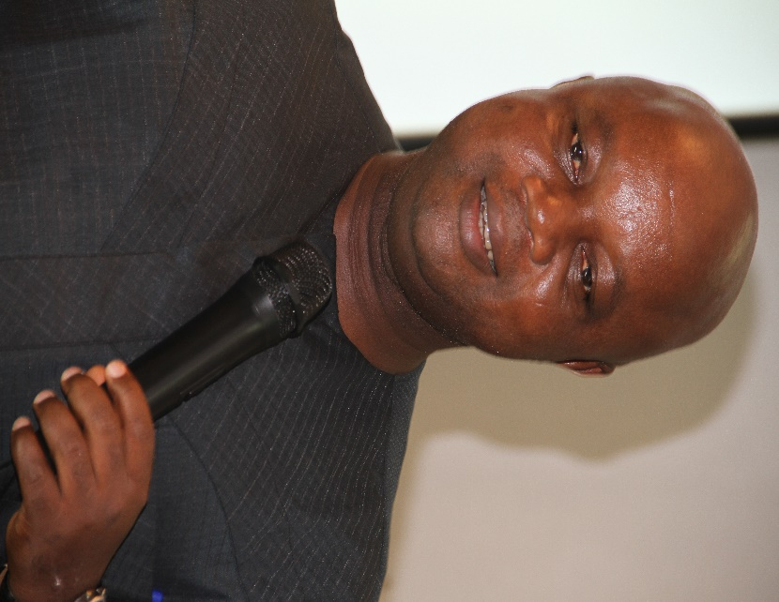
Mr. Monday Osasah, a fellow of the Institute of Management Consultants of Nigeria, holds a master's degree in public administration and a bachelor's degree in economics from the Delta State University, Abraka, Delta State. He was Bureau Chief of the Niger Delta Voice, a Newspaper that chronicle the voices of the people of the Oil rich Niger Delta region (now defunct), and later the Bureau Chief of the Urhobo Voice Newspaper, an ethnic tabloid also in the Niger Delta. He was Secretary of the League of Patriotic Deltans, a socio-political pressure group that engages government and its agencies on the delivery of democracy dividends and good governance. He is a development expert with vast experience in governance, leadership, election, monitoring and evaluation, media relations, capacity building, power analysis, team building, report writing, policy and policy development and strategic planning. His other areas of interests include; facilitation of community scorecard and charter of demand development process. He is currently the Executive Director of the African Centre for Leadership, Strategy & Development (Centre LSD), faculty member of the Centre LSD Leadership School and the Administrative Secretary of the School. He is currently the Secretary of the Civil Society Task Team on Election Security in Nigeria and chairs the board of several non-governmental organizations in the country.

JOHNSON IKUBE
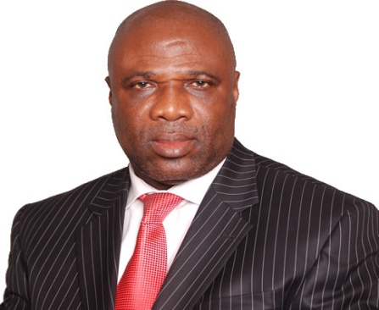
Mr. Johnson Ikube has over 42 years of deep, broad, multi-function work experience in Banking & Finance, Consulting, Manufacturing, Construction, Public Sector, Community Service and Learning Interventions. His overlapping functions within the levels and sectors cover Strategy, Internal Consulting, Customer Care, Resourcing (Human & Internal Services), Audit & Internal Control, Accounting and Financial Management. He was involved at Executive Management Level with the restructuring, consolidation and turnaround of Crystal Bank of Africa Limited to Standard Trust Bank Plc. He consulted for United Bank for Africa Plc as Culture Change Consultant for over 7 years to 30.09.2016. His Group facilitated the 3rd Phase of the next level transformation agenda of Abbey Mortgage, a Primary Mortgage Institution.
He is currently, the Group CEO of JI Holdings Limited, a Group with core interests in Business Strategy & Performance Consulting, Investment, Services, Executive Resourcing, Attitudes and Behaviour Modification, Executive Coaching Services. He evolved this Group over the last 18 years after having risen to the level of Executive Office Consultant in Standard Trust Bank Ltd (now merged with United Bank of Africa Plc.) He is a Chartered Management Accountant and Marketer with the degree of Masters, in Business Administration. Mr. Ikube’s life philosophy? “Raise himself, others and organisations to focus on what is good and to do it rightly at all levels - individual, family, societal, national and global”. He has to his credit articles and papers covering many aspects of business, life and living. His hobbies and interests are: Reading (philosophical, spiritual, business & economic materials), travelling & tourism, listening to classical and light music. He is a Chartered Management Accountant and Marketer with the degree of Masters, in Business Administration.

EJIRO J. OTIVE-IGBUZOR
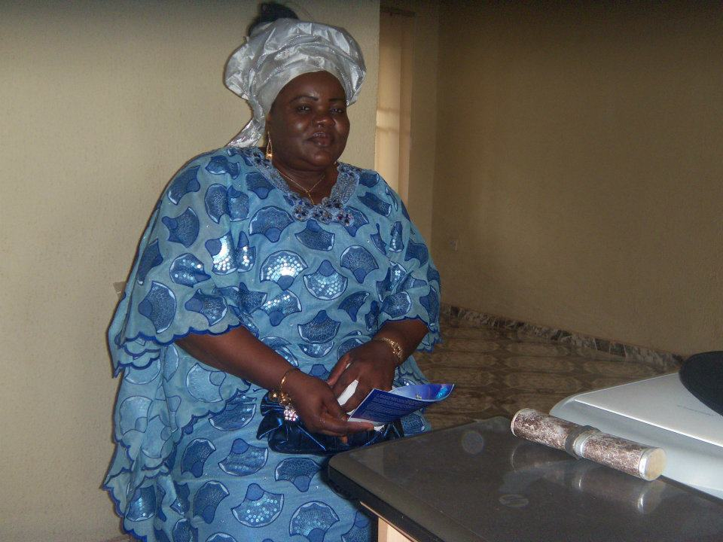
Ejiro J. Otive-Igbuzor, holds a PhD in Microbiology (Majored in TB-HIV Co-Infection). She is a Gender and Monitoring and Evaluation expert. She currently runs Gender and Monitoring and Evaluation Institutes in Nigeria. She worked previously as the Nigeria Country Director of the Centre for Development and Population Activities (CEDPA); Gender and HIV/AIDS Programme Coordinator for UNIFEM (now UN Women); Anglophone West Africa; Research Lead, Voices for Change; Senior Programme Officer, the POLICY Project; Research Fellow, Nigerian Institute of Medical Research and Lecturer, Ramat Polytechnic, Maiduguri, among others. She currently works as the Managing Director/Chief Executive Officer of Emerald International Development Services (EIDS) Limited and has provided consultancy services to local and international clients in several thematic areas including project design, monitoring and evaluation, curriculum development, research and documentation, gender audit, strategic planning, advocacy toolkit development and training.
Ejiro is a seasoned writer,Among her published works are Monitoring and Evaluation Demystified, HIV/AIDS, Human Rights and Women in Nigeria, Deadly Paradise, Analysis of the Systemic Causes of Gender Inequality in Nigeria (A V4C research paper), Gender and HIV/AIDS: Rethinking Women’s Vulnerability Beyond the Biological Paradigm. Ejiro has a rare combination of skills. She is a Gender expert and a Monitoring and Evaluation Specialist. She writes scientific papers and doubles as a playwright and Poet. She has several published papers to her name. She is the Assistant General Overseer of Palace of PRIESTS ASSEMBLY, Abuja. In addition, she Coordinates the Gals Global Hangout, a share and learn platform with over 500 women across the globe empowering women to fulfill their potentials maximally.

OBOT OBOT

Mr. Obot Obot is from the banking sector. He brought into the team over two decades of banking experience with professional conduct and Ethics Certification, half of which is at the branch management cadre which spans banking operations, personnel administration, marketing, advances, bills and credits and customer relationship management. He holds a Bachelor of Science Degree (BSc) Hons. in Public Administration, University of Port Harcourt, Masters of Business Administration (MBA), Ambrose Alli University, Ekpoma and has also completed Masters of Science (MSc) in Policy and Development (awaiting result), Ambrose Alli University, Ekpoma. A trained strategic resource and cost manager, and also undergone training in Advanced Management Development courses, Product Development,Credit Management and Control.He has passion for exemplary and effective leadership, poised to contribute to the advancement of Global Community by providing opportunities for young people to develop leadership skills, social responsibility and fellowship necessary for positive change in society. Member, Sharmar Educational Foundation, Delta State an NGO with a vision of getting children back to school. Currently, Chairman Board of Directors, Christ Ambassadors Student's Outreach (CASOR) Fellowship, Assemblies of God Nigeria, Ughelli District and President, Graduate Fellowship (CASOR Alumni Fellowship) aimed at reconciling people to God. An Entrepreneurial Development trainer,Policy analyst, organizes seminars, symposiums and lectures for self-Development and Leadership across Nigeria. Happily married and blessed with children.

ETIM, ISRAEL ESSIEN

Pst. Etim Israel, is presently the Chief Executive Officer (C.E.O) of the All Nations Gospel and Evangelistic Association, Worldwide, whose drive is to finish well in Christ as he fulfills Gods purpose for his life. He has served as a Resident pastor, District pastor, Zonal pastor and Provincial pastor at the Winners Chapel International, church from 1998-2013, where he held the position in oversight of all mission station operations, including mission school during his service. He is a graduate from the University of Calabar where he holds a Bachelor degree in Agriculture Soil Science. Pastor Etim has also served as an Operational Manager in Dolly Sewing Institute, Lagos State (purchasing of store items, stock control, machinery and human resource management). He also served as Plantation Officer with the European Economic community (EEC)/Katsina State Government Afforestation Project which duties includes(data collation and processing Ad hoc staff training). He is also the Managing Director of Kings Daily Baker, Port Harcourt and the Director of Operations, ShinningLightInterbiz Logistics Ltd. He is a professional skilled administrator with solid experiences in managing different levels of multiple project including budgeting and finance administration. He is experienced in effective leadership/ versatility in computer system, exceptional inter- personal communication, budget development /finance management, store control/store management, staff training/development/employee scheduling, Customer service oriented, effective multi-tasker/deadline and target oriented.

ONYI IKEMEFUNA

Amb. Dr. Mrs. Onyi Ikemefuna is a committed wife and mother who has a broad academic and professional background in the following areas; childhood education, peace education/training for youths and women finishing school, cutting across all adult age group.
She is the Administrative Director of Shamar Educational Foundation (SEF) has been working closely with World Mission Foundation [aiding initiative in special consultative status with the United Nations Economic and Social Council, CSW] as the Africa Rep. and International relations director. A member ACEI (Association for Childhood Education International), she is the ambassador for Women’s health Days for Girls and member of other social working committee on children, youths and women development. She has been standing in for global peace education, participating in curriculum development programs, providing scholarship schemes for communities in Nigeria to secure the future. Water project in kolokolo community, toilet project in Udu L.G.A, free retraining for some teachers in some states(Non-Governmental), charity fair, women and youth skill acquisition in most communities in Nigeria. She recently embarked on building literacy corner for one million children in Nigeria.
She has received numerous awards for her humanitarian service. She received a citation of recognition from the Mayor of the incorporated village of Valleystream Edwin A. Fare on April 2nd, 2012 for being dedicated to building free schools in Africa. Recently she started an advocacy on one million friends of education who would put indigent children back to school and designed a new program for parental participation in schools called PTPF (Parents, Teachers Performance Forum). During the 2013 Niger Delta flood, Shamar Educational Foundation gave relief and provided individualized learning/counselling for the victims whose houses were displaced.
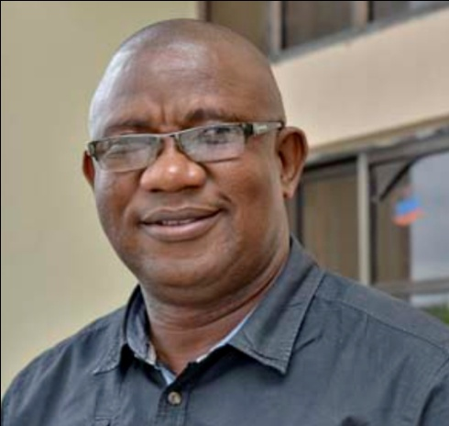
SYLVESTER OKOH
Mr. Sylvester Okoh is a professional in enterprise development with deep focus on micro, small and medium scale enterprises, value chains and market linkages. He comes with over 29 years cognate experience in agriculture and rural development, market systems development, project finance, micro credit, training and capacity building, partnership management, advocacy and sustainable development. Sylvester is a trained Partnership Manager from The Partnership Initiative, Oxford University, UK, holds a Master’s Degree in Business Administration and a B.Com (Hons) in Accounting. He is a Fellow of the Association of Business Specialists & Entrepreneurs of Nigeria and a Member of the Chartered Institute of Mediators and Conciliators. Prior to working in PIND Foundation Sylvester was Manager, Enterprise Development, Rivers State Sustainable Development Agency. He was also Head, Economic Empowerment at The Shell Petroleum Development Company of Nig. Ltd. (SPDC) and a pioneer staff of TechnoServe/Nigeria, an international development organization that works with enterprising people in the developing world to build competitive businesses. He has passion for pro-poor development, market systems approach to sustainable development and believes in adding value to life. Sylvester is currently the General Manager, Community & Government Relations, Heritage Energy Operational Services Ltd, an Oil & Gas company operating in the Niger Delta.

MONDAY ITOGHOR
Chief Monday Ogheneruona Itoghor is the CEO of Environmental and Rural Mediation Centre (ENVIRUMEDIC), based in Warri, Delta state, Nigeria. He is a trained Environmentalist in Nigeria, Climate Change Expert from Sweden and Program and Project Mgt and Administration from the Netherlands. ENVIRUMEDIC is a non - governmental organisation that works with poor and excluded people. He has touched lives through this centre including children, Physically challenge Persons and the People living positive. He is Development Expert, an Environmentalist with great skill in GIS. He facilitates training on Accountability and Budgeting, Voice and Power and Economic Literacy and Budget Accountability for Governance (ELBAG) across African countries. These countries include; Tanzania, Uganda, Gambia, Ghana, Mozambique and Sierra Leon and Nigeria. He has carried out capacity building on climate change mitigation and adaptation measures through REFLECT Circle Meetings across various rural communities of the Niger Delta Region. He has attended over 30 trainings both home and abroad and well-grounded on Governance issues.
TIVE DENEDO
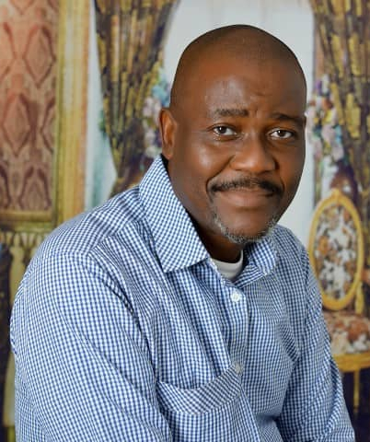
Tive Denedo, CEO of Sunfair Communications Limited is the Executive Director of Lets Study Initiative, He is the immediate past Campaigns Director of Media Rights Agenda, the civil society organization that worked for the passage of the Freedom of Information law in 2011. He was a former staff of The Guardian Newspaper, Copy Editor of The News Magazine and publisher of the defunct Sportline magazine. He has extensive conference and seminar training experience in Nigeria, South Africa, Kenya, the ECOWAS sub-region, Europe and the United States of America. He is the Vice President of the Institute for Negotiation and Peace Practice, member of the Journalist Network for Peace and a regular contributor on national issues in Nigeria newspapers and television stations. He is a content creator for broadcast, Online and newspaper organisation and the creator of the now rested magazine Television programme Oriental Express which ran on African Independent Television. He is currently the Programme Manager of the Peace Peace and Justice Initiative.

PRECIOUS AGBUNNO

Dr. Precious Agbunno is an Enterprise and Market System Development Specialist with extensive experience in designing and implementing programs aimed at supporting small businesses to grow and small hold farmers in different agricultural value chains to increase their productivity and income. He currently manages the Chevron Corporation Funded PIND Foundation's Market Systems Development Project that comprise five agricultural value chains projects and two cross cutting projects. The projects are designed to support small farmers and enterprises to become more productive to increase their earnings and incomes. He has over 17 years’ experience working with different individuals and institutions in both the private and development sectors. He holds an M.Sc. (Distinction) in International Finance and Economic Policy from the University of Glasgow in Scotland and a BSc in Accountancy from the University of Nigeria, Nsukka. He has attended various courses in leadership, business management and enterprise development, and value chain analysis and development, including the Springfield's Making Market System Work training course.
OSAWARU STEPHEN
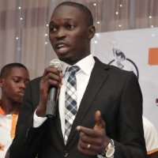
Mr. Osawaru Stephen A Computer Scientist, with a B.Sc. in Statistics with Computer Science, a Master’s in Business Administration and Certificate in Entrepreneurial Management at Enterprise Development Centre, Pan Atlantic University (Lagos Business School). Have a certificate in Digital Entrepreneurship at Fate Foundation. Stephen is Microsoft Certified Information Technology Professional and Microsoft Certified Systems Engineer. Stephen had a 1-year Leadership/Management training and certification at African Centre for Leadership, Strategy and Development.
Awards: He’s an awardee of youth with innovation in Nigeria (Federal Government award for innovation). A recipient of the South South Innovation award from the office of the Vice President, Federal Republic of Nigeria A recipient of the Presidential Standing Committee on Innovation and Invention Award. A recipient of Building Entrepreneurs Today (BET7) award by diamond bank Plc Leadership Champions Award for developing others, African Centre for Leadership, Strategy and Development, Abuja. Presently incubated at the South-South Innovation hub and was one of the 10 selected startups who pitched to the Vice President during the launch of South-South Innovation Hub. Stephen work to support start-ups during the formative period of their businesses, helps the start-up companies to find resources to make the entrepreneurship process easier and shorten their learning curve which is the essence of the incubation program (Ignite StartupX). Stephen presently serves as the state vice chairman of Nigerian Association of SmallScale Industrialists, Edo State. A community of over 300 startups

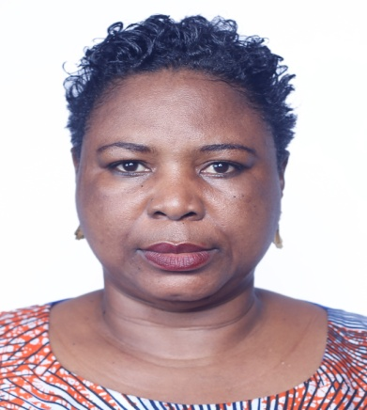
RACHAEL MISAN-RUPPEE
RACHAEL MISAN-RUPPEE, is an educationist, trainer, radio talk show host, women rights activist, and a development consultant. She holds a Bachelor and Masters of Science Degrees in Social Studies, from Delta State University Abraka. Presently pursuing a PhD at the same Institution. She is the founder of Development Initiative for Community Impact. She has over 12 years-experience as a Development worker, which include programming and facilitation of women advancement, elimination of SGBV, promotion of Human rights, monitoring and evaluation. She is a member of professional bodies and coordinator of several Networks/Groups. She has carried out different activities, a to ensure a peaceful and economically vibrant society.
BRIDGET ANYAFULU

Barr. Bridget Anyafulu easily stands out as a leading Icon in the highly demanding and challenging World of Civil Society Organizations in Nigeria and in the dispora where she is increasingly carving out a niche for herself as a frontline advocate for Gender Equality, Family Planning and Reproductive Health Rights of Women, Maternal Health, Child Rights and Social Progress. Today Barr. Anyafulu serves as the Senior Special Assistant to the Executive Governor of Delta State, His Excellency, Senator, Dr. Ifeanyi Arthur Okowa. Following her appointment on the 1st of June 2016, on the 3rd of June 2016, she signed off from her office, where she presided over as the Executive Director of Int’l Centre for Women Empowerment and Child Dev. (ICWECD), a Non-Governmental Organisation which she founded in 2004 with the Vision to promote the Rights and the empowerment of Women, support the development of Youths and Children, their Rights as well as the Under Privileged Persons. A native of Asaba the Capital City of Delta State, Barr. Bridget IfechukwukwuAnyafulu holds a Masters degree in law (LLM). Barr. Anyafulu has had extensive experience in the Media where she started her working life. A member of the Amnesty International, the Nigerian Bar Association (NBA), Network of the Bar, Bench and Police on Reproductive Health, the International Federation of Female Lawyers (FIDA) as well as the Civil Liberties Organization (CLO). As a Development Consultant, Barr. Bridget Anyafulu works with Women and Children as well as mentors the youth. She currently serves as the Co-ordinator of the White Ribbon Alliance for Safe Motherhood in Delta State, a position she holds according to the letter of appointment for her devotion and commitment to the cause of Women. Over the years Barr, Anyafulu has worked actively in collaboration with National Council of Women Society (NCWS) and the Network of the Bar, the Bench and the Police on Reproductive Health to promote and protect the rights of women and children especially the adolescent girls across the Country. In June 2013, she was the Nigerian among the four Africans appointed to serve as core members of the Rights and Empowerment working Group of the FP2020 of the United Nations Foundation and in April 2016 she was appointed to serve as a member of the Expert Advisory Community (EAC) to harness the vast expertise and energy of the Global Family Planning Community and to continue to advance the important work set in motion through FP2020`s Working Groups.
BARR. OMEMIRORO OGEDEGBE

Barr. Omemiroro Maxwell Superior Ogedegbe undoubtedly is and exciting but quiet personality in Nigeria and goes with the code name Omes Ogedegbe. He was born to the family of Captain and Mrs. Superior Ogedegbe of Kiagbodo, and a scorn of the great legendary Bekederemo. He had his elementary education at Alegbo primary School, Effurun and John F. Kennedy Nursery, Primary and Secondary School Effurun, Delta State. After his somewhat academic sojourn, he proceeded to the Delta State University where he was admitted to the noble degree of Bachelors of Law (LLB Hons) in 2005. While in the University, he exhibited his penchant for activism, which saw him as and activist and a human right crusader and was in various human right organizations.
In recent times he has championed the cause of the down trodden in the society as demonstrated in his action filled in court to challenge the intended ban by the Delta State government on the use of commercial motor cycle in Delta State. The action was duly filed at the Delta State high court, Effurun, Delta State and when the action was transferred to Asaba (the C.J’s court) the state headquarter he made representation before the state Chief Judge urging the State Chief judge to excuse himself from conducting the trial of the case as his involvement will create an impression of executive interference in the administration of Justice.
He is the current Director General of the Conference for the Actualization of Human Right.

OBI ELOHOR ROSE
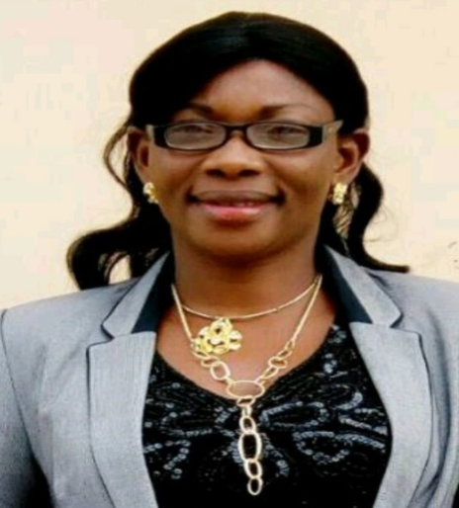
Mrs. Obi Elohor Rose, An Educationist with special interest in youth development, and holds a Master’s Degree in Guardian and Counseling and a bachelor’s degree in marketing from Delta State University, Abraka, Delta State, while PGD in Education from University of Port-Harcourt. She is the Proprietress of City Child Foundation Schools, Ekpan, Delta State. She is Currently the Chairman, National Association of Proprietors of Private Schools Owners (NAPPS), Uvwie LGA Chapter, Financial Secretary, Counseling Association of Nigeria, Delta State, and Secretary, Federal Road Safety Corps, Special Marshal unit 6. She is a passionate teacher, motivational and public speaker that has anchored several public events/functions. As part of her numerous humanitarian service, in 2014, she single handedly renovated and fixed a block of 12 Toilets with water system at the Girls Hostel, Federal Government College, Warri. She is happily married with children and a devote Christian and member of the Redeemed Christian Church of God.

PROFILE OF ADMINISTRATIVE MEMBERS


EGEDEGBE JOY
Egedegbe Joy is a Computer Scientist, Gender Officer and Safety officer with Value Rebirth and Empowerment Initiative (VREI), Head administration, ValueRebirth-CentreLSD Leadership School, Effurun-Warri Study Centre.

NEFERTITI AYO OKOTIE

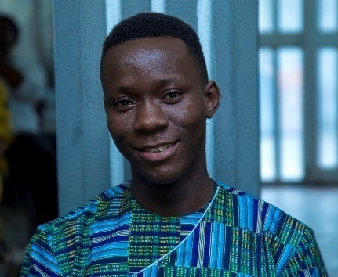
Nefertiti Ayo Okotie is an educationist with passion for women and youth development, and Executive Director, NEFEROK Development Initiative. First Deputy Governor, Value Rebirth-Centre LSD Leadership School, Effurun-Warri Study, 2017/2018 session.


STELLA ODIKA
Mrs. Stella Odika is a Senior Executive Officer (Information). The PRO, Warri/Uvwie and Environs Special Area Development Agency (WUEDA). An Associate Member of the Nigerian Institute of Public Relations (ANIPR). A Real Estate Consultant. The Team Lead, Inspire-Net Initiative. A Motivational Speaker, Teenage Coach, Mentor, set 1 graduate and commissioner for information 2017/2018 session and currently an administrative member of the centre.

EYELA EMMANUEL
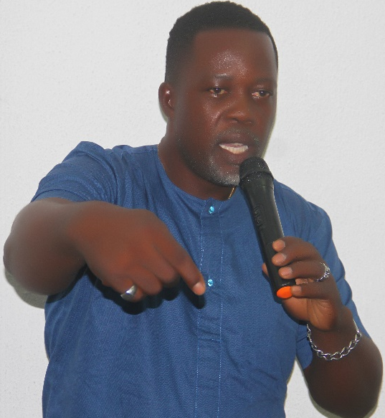
Emmanuel Charles Eyela, a graduate of Delta State University Abraka where he obtained a Bachelor of Science (Hons.) in Business Administration, and Master of science (M.Sc) in Business Management in the same institution. Emmanuel Charles Eyela is a graduate and Class Governor, set 2, Value Rebirth- Centre LSD leadership School, Effurun-Warri Study Centre 2018/2019 session.He is currently an administrative member of the study centre, the C.E.O of Emmalee Systems Nig., and presently the Special Adviser (S.A) to Uvwie LGA Executive Chairman. Hon. Ramson TegaOnoyake.

FERDINAND N. EZEUGO
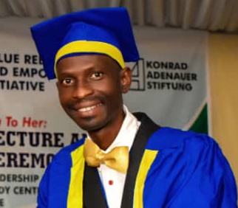
Ferdinand N. Ezeugo is a graduate of computer science, IMT, EnuguState and currently into Poultry Farming/Consultancy, a graduate of Value Rebirth-Centre LSD Leadership School, Effurun-Warri Study, 2018/2019 session. He is currently an administrative member of the centre.

MICHAEL OSARODION OKORO
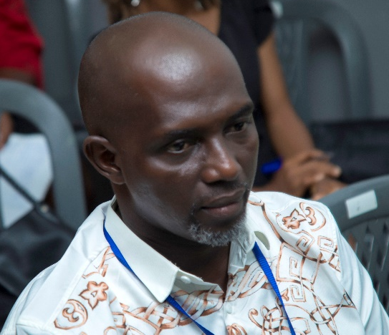
Michael Osarodion Okoro (JP), is a Member, Institute of Professional Managers and Administrator. Senior Manager, Darrel Agro and Allied Products Co. Ltd., and holds, M.Sc in Business Management, Delta State University, Abraka. He is a Real Estate Consultant. And His Set 2 graduate 2018/2019 session and currently an administrative member of the centre.

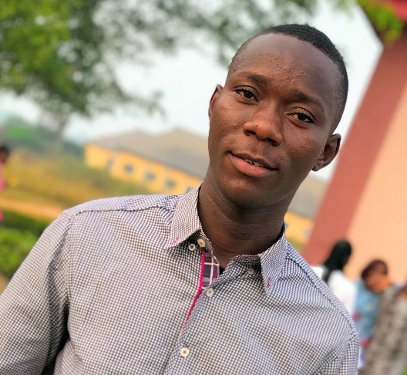
ITULE OGHENETEGA BRAVE
Itule Oghenetega Brave is the Ag. Program Officer with Value Rebirth and Empowerment Initiative and Administrative Officer, Value Rebirth-Centre LSD Leadership School, Effurun-Warri Study. He is a Higher National Diploma in Banking and Finance, Delta State Polytechnic Otefe-Oghara(in view), and Set 1 graduate of Value Rebirth-Centre LSD Leadership School, Effurun-Warri Studycentre, 2017/2018 session.

