REPORT OF VALUE REBIRTH AND EMPOWERMENT INITIATIVE (VREI) IN PARTNERSHIP WITH THE AFRICAN CENTRE FOR LEADERSHIP, STRATEGY AND DEVELOPMENT (CENTRE LSD) ON HER 3RD ANNUAL LEADERSHIP LECTURE/GRADUATION CEREMONY OF 3RD SET OF LEADERSHIP SCHOOL, EFFURUN-WARRI STUDY CENTRE WITH SUPPORT FROM KONRAD ADENAUER STIFTUNG (KAS) HELD ON SATURDAY 29TH AUGUST, 2020 AT PTI CONFERENCE CENTRE, EFFURUN, DELTA STATE.
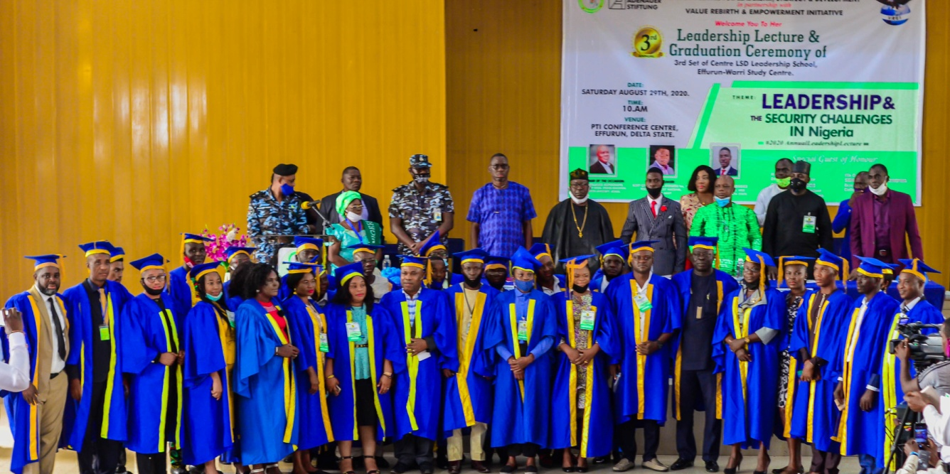
Executive summary
The 3rd Annual Leadership Lecture and graduation ceremony of Set 3 students of the Value Rebirth- Centre LSD Leadership School and the matriculation of incoming 4th set of students held 29th August, 2020 at PTI Conference Centre, Effurun, Delta State. This year’s annual lecture themed “Leadership and the security challenges in Nigeria’’, was carefully chosen owing to the rise of insecurity in the country and the urgent need to advocate and enlighten citizens on peaceful and harmonious co-existence among Nigerians in order to avoid lost of lives and properties. It is imperative that we begin to raise leaders and develop quality leadership skills for all times, that Value Rebirth and Empowerment Initiative (VREI) in partnership with the African Centre for Leadership, Strategy and Development (Centre LSD) with support from Konrad Adenauer Stiftung (KAS), a German political Foundation put the lecture together.
The Executive Director of VREI and Director of Studies at the Effurun-Warri Study Centre of the Leadership School, Pst. Edewor Egedegbe in his welcome address informed the gathering that a total of 78 students out of 110 admitted will be graduating today and when added, Effurun-Warri Study Centre would have graduated 182 students since inception.
The Executive Director of the African Centre for Leadership, Strategy and Development (Centre LSD), Mr. Monday Osasah, in his remark said the idea of starting the leadership school was borne out of the realization that leadership is a major problem especially in Africa. He pointed out that many scholars and commentators are in agreement that leadership failure is one of the major factors responsible for the underdevelopment of Africa. He said however, it has been proven that leaders can be trained which is why the Centre LSD Leadership Abuja is designed for people who want to become leaders and be equipped with leadership skills for transformation of organizations and society. He noted that, the school runs for free annually and the leadership school started in 2009 under the auspices of the Ejiro & Otive Igbuzor Foundation but was transferred and became a flagship programme of the African Centre for Leadership, Strategy & Development (Centre LSD), on the establishment of the Centre in 2010.
The chairman of the occasion, Prof. Williams Akpochafo, a Professor of Social Studies Education, Delta State University, Abraka, who was represented by Dr. Oghounu Eric, in his opening remark, commended the efforts of the school for grooming leaders, and urged everyone to embrace integrity, moral principle, social justice for the betterment of society.
Goodwill messages were delivered by the following persons; H.E, Sen. Ovie Omo-Agege (Deputy Senate President, NASS) represented by Hon. Chucks Erhire, Hon. Ramson Onoyake (Executive Chairman, Uvwie LGA) represented Pst. Pst. Joseph Isaac (JP), Commissioner of Police, Delta State represented by CSP Udeviotu Onyeke, Commanding Officer, 3 Battalion, Nigeria Army, Effurun Barrack, Delta State represented by Major Suleiman Abdul, Amb. Dr. (Mrs.) Onyi Ikemefuna,
The leadership lecture with the theme: Leadership and the security challenges in Nigeria was delivered by Navy Capt. Hermans Efenudu, fwc,rtd, Former Provost Marshal, Nigeria Navy. The lecture focused on the following;
- Introduction to the subject matter
- Leadership concept
- Security Challenges
- Relationship between leadership and good governance
- Indicators of good Governance
- Overview of leadership and good governance in Nigeria since independence
- Effects of leadership on good governance in the fourth republic
- Issues with our politics
- How leadership relates with security challenges, among others.
The paper was discussed by three discussants drawn from the graduating students. The governor valedictory speech was read by the set 3 class Deputy Governor, in his valedictory speech appreciated all those present at the ceremony and encouraged the graduating students to be true leaders wherever they find themselves. Graduands gave testimonies of how the Leadership School imparted them and certificates were presented to those who met all requirements. Awards were given to deserving graduating students and award of excellence was also given to a deserving dignitary.
The newly admitted set 4 students took their Matriculation Oath before Mr Obot Obot. The ceremony was witnessed by some set 1 & 2 students of the Leadership School.
The 3nd annual leadership lecture/graduation ceremony had a massive coverage by the media, over 100 persons were in attendance.

Preamble
The 3rd Annual Leadership Lecture and graduation of the 3rd set of students of the Value Rebirth-Centre LSD Leadership School/matriculation of the 4rd set of students held on 29th August, 2020 at PTI Conference Centre, Effurun, Delta State. The idea of the Effurun-Warri Leadership School was set up to train leaders by attempting to unravel the complexity of leadership and offering a framework that will help people to become great leaders. This year’s annual lecture themed “Leadership and the Security Challenges in Nigeria” was carefully chosen owing to the rise of insecurity in the country and the urgent need to advocate and enlighten citizens on peaceful and harmonious co-existence among Nigerians in order to avoid lost of lives and properties. According to online publication by allafrica.com/stories on the 3rd November, 2017 shows that 2,500 people killed, 62, 000 people displaced, $13.7billion lost to the clashes and 47 per cent of internally generated revenue in the affected states lost to famers/herdsmen clashes in 2016. It becomes imperative that leaders are raised among the youths and aged, which is why the African Centre for Leadership, Strategy and Development (Centre LSD) in partnership with Value Rebirth and Empowerment Initiative (VREI) with support from Konrad Adenauer Stiftung (KAS), a German political Foundation put the lecture together to enable students who have passed through leadership training for one year to understand some etiquette of security by playing active role in the security of the country .
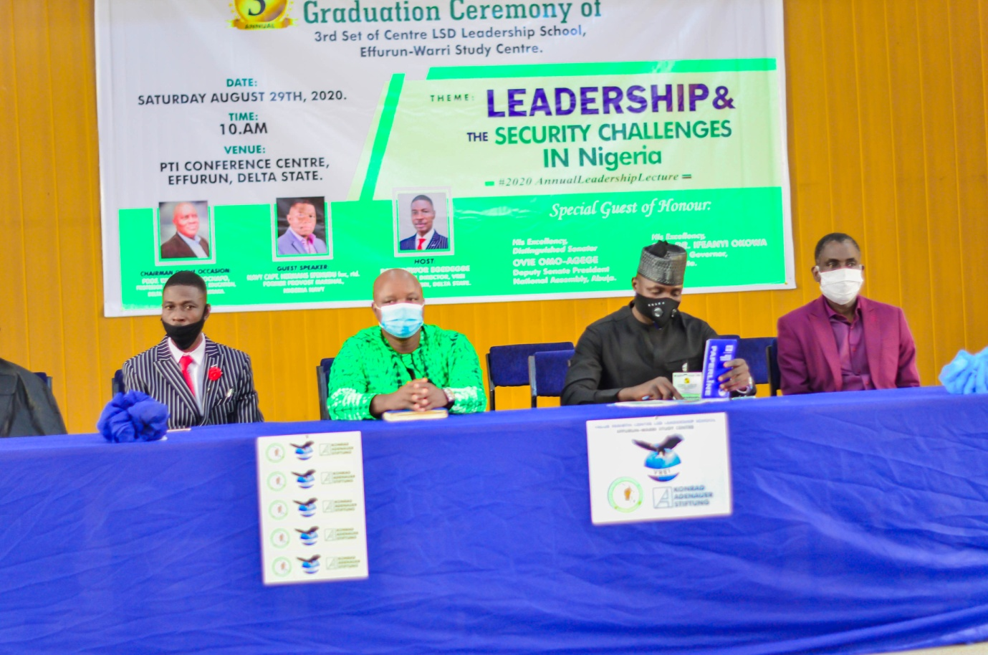

Welcome Address by Executive Director, VREI
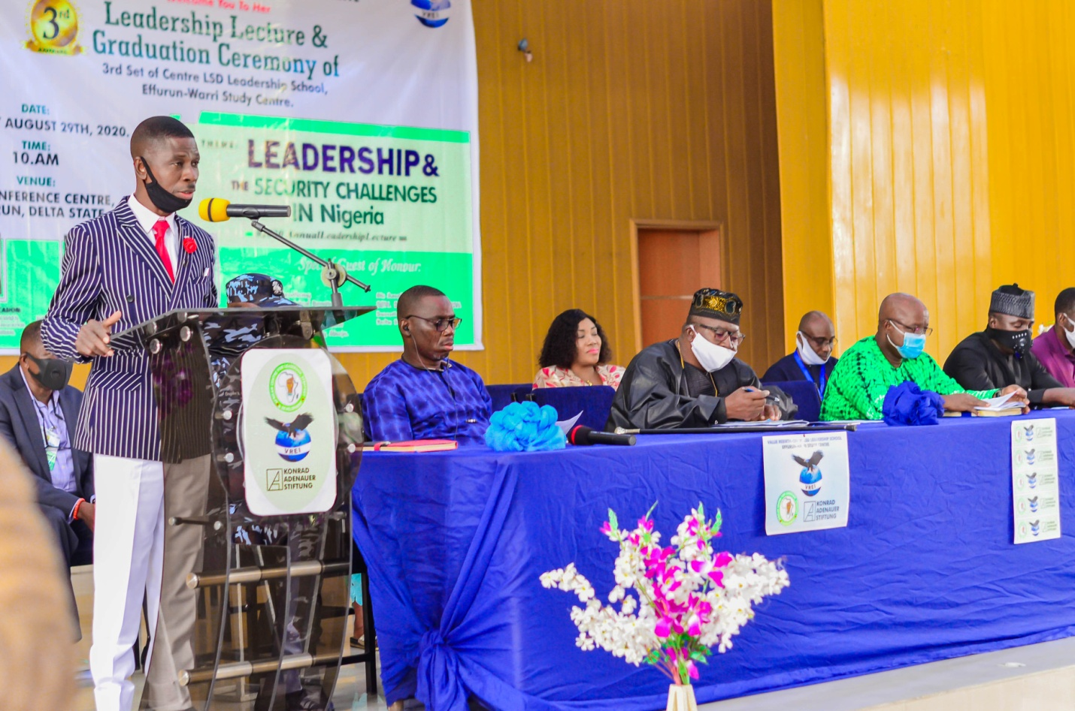The Executive Director of VREI and Director of Studies, Value Rebirth-Centre LSD Leadership School, Effurun-Warri Study Centre, Pst. Edewor Egedegbe in his welcome address gave a brief account of how the Leadership School, Effurun-Warri Study Centre started in June, 2017 as the first of its kind in the South-South (Niger-Delta), in a bid to train leaders by attempting to unravel the complexity of leadership and offering a frame work that will help people with focus on leader development and leadership development. The Director of Studies shared his organization’s (VREI) vision, mission, value and pointed out that since inception, Value Rebirth and Empowerment Initiative have been committed to its thematic focus in Peace Building, Civic Education, Governance and Environment and have intervened in several governance and peace related issues such as election observation, leadership training, conflict mitigation/peace building, tax justice platform, gender based violence eradication, community leadership enhancement among others. He also informed the gathering that the Leadership School which is free runs for a year holds its graduation/matriculation ceremony every May since inception except for this year as occasioned by covid-19 pandemic, 78 out of the 110 students admitted will be graduating in the 3rd set and when added, Effurun-Warri study centre would have graduated 182 students since inception. He made it known that for the next leadership academic session, over 100 applications have been received and 105 persons have been shortlisted for admission.
The Director of studies took advantage of the welcome remark to share his experience as a student of the Leadership School. 2012/2013 academic session. He said his quest for knowledge and also to be a solution to the multifaceted leadership challenges across Africa, Nigeria and in particular the Niger-Delta which occupies 7.5% of the total land area of Nigeria, 70,000km², and is home to approximately 30million people was a major impetus for his interest and subsequent training at the Centre LSD Leadership School, Abuja, where he was trained free of charge with others from different States across the federation for one year. He said he travelled to Abuja every third Saturday to acquire this much needed leadership knowledge, the mother of all knowledge because, the success and failure of any system be it spiritual or physical depends largely on leadership and painstakingly, he followed every lecture that was presented with passion, and contacted so much grace and insight each month he attended. The Leadership School training and the inspiration from the Holy Spirit gave rise to the establishment of his organization, Value Rebirth and Empowerment Initiative.
In addition, Pst. Edewor Egedegbe informed the audience that as part of the requirements for graduation, students were grouped to carry out Community Development Service (CDS) and they delivered life transforming projects during the session as indicated below;
Group 1: Reaching out to the needy: Presentation of food items to an orphanage home (Eagle Hand Foundation), Warri, Delta state.
Group 2: Seminar Presentation on effective leadership to teachers of Ugbolokposo Secondary School, Effurun, Delta State.
Group 3: Installation of traffic road signs across strategic points in Uvwie Local Government Area, Delta State
Group 4: Sensitization on Effects of Teenage Pregnancy in Society to students of Ugborikoko Secondary School, Ugborikoko, Uvwie LGA, Delta State.
Group 5:Sensitization on the Menace of Social Vices among Students in Effurun-Warri at Army Day Secondary School 1, Effurun, Delta State.
Group 6: Sensitization against drugs and cultism at Uwangue College, Warri, Delta State.
Group 7: Combating Cultism among Secondary School Students at Opete Secondary School, Enerhen Road, Delta State.
Group 8: Teenage Pregnancy: Effects on Girl Child Education and Prevention at Alegbo Secondary School, Alegbo-Effurun, Delta State.
Group 9: Construction of Pedestrian Wooden Bridge linking Ugboroke/Ugborikoko communities, Uvwie L.G.A, Delta State.
Group 10: Presentation of Note Books to Pupils of Egbo Primary School, Egbo-Uhurie, Ughelli South LGA, Delta State.
He appreciated the management and staff of African centre for Leadership, Strategy and Development (Centre LSD), and Konrad Adenauer Stiftung (KAS) for their partnership and support, and also commended the efforts of Amb. Dr. Mrs. Onyi Ikemefuna, founder of Shamar Children School, a long standing faculty member of the leadership institute who has graciously offered her school hall for set 4, lecture.
Finally, he appreciated three other categories of people for their contribution towards the continued success of Effurun-Warri study centre. They include; the set 3 graduating students, faculty members (who offered selfless service without being paid), staff of VREI for their immense contributions.
Remark by the Executive Director, Centre LSD, Mr. Monday Osasah.
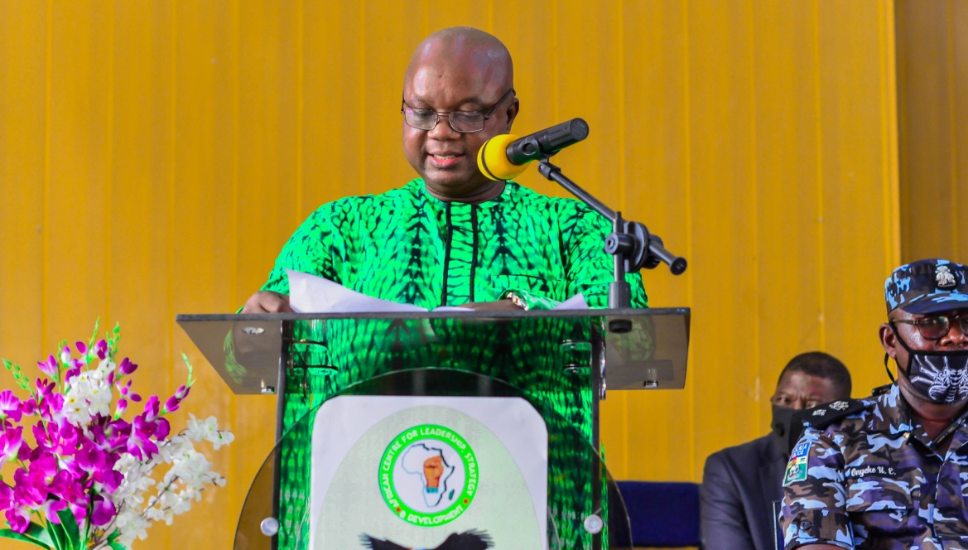
The Executive Director of the African Centre for Leadership, Strategy and Development (Centre LSD), Mr. Monday Osasah, in his remark said the idea of starting the leadership school was borne out of the realization that leadership is a major problem especially in Africa. He pointed out that many scholars and commentators are in agreement that leadership failure is one of the major factors responsible for the underdevelopment of Africa. He said however, it has been proven that leaders can be trained which is why the Centre LSD is designed for people who want to become leaders and be equipped with leadership skills for transformations of organizations and society. The school he said provides students with tools and ways to have vision for leadership and become better leaders. He noted that school runs for a period of one year and the Centre in Abuja runs two sets consecutively every year, as well as other leadership programmes-Leadership Institute and Executive Leadership Course. The graduation of the 12th set of students was held last Saturday August 22, 2020 in Abuja. By September 5th, 2020, we shall be holding the graduation of the 13th set also in Abuja. So far, the Centre has trained and graduated 917 students. Furthermore, he added that, the leadership school has three study centre outside Abuja centre which includes, Effurun-Warri (Delta State), Port Harcourt, Rivers State and Benin City, Edo State, noting that, that Centre LSD Leadership Schools have continued to maintain standard by ensuring that classes take place in good venues with quality lecturers of good values and morals, and the core courses are taken. Any Leadership school can add any additional course to suit local peculiarities, but all the core courses must be covered. The lecturers must be well educated, experienced and good facilitators of training. Mr. Monday Osasah who also represented Dr. Otive Igbuzor, Founding Executive Director, Centre LSD, Abuja noted he was asked by the Dr. Otive Igbuzor to encourage graduands and other participants to be involved in politics in order for inferiors not to rule them in the days ahead.
Also, the Centre is exploring the possibility of partnering with Universities to run courses on Leadership Studies that will lead to the award of Certificates, Diplomas and degrees, and when this becomes operational, graduates of the leadership school will have credits allocated to them based on the courses already taken and after examination will spend less time for the award of the certificates, diplomas and degrees in Leadership studies.

He described the choice of the theme: “Leadership and the security challenges in Nigeria” is indeed apt following what we are currently going through as a country. There is hardly no region of the country without one form of security challenge or the other. Therefore, highlighting and chronicling the issues in a forum such as this to collectively proffer solution to the menace is not only important but imperative. I am glad about the choice of the guest lecturer, Navy Capt. Hermans Efenudu fwc, rtd, a man who has sufficiently distinguished himself in the Nigerian Navy. We are confident he will bring his wealth of experience to bear on the theme, and proffer solution(s) that will help to change the security narrative in Nigeria.
He concluded by appreciating the chairman of the occasion, Prof. Williams Akpochafo, Pst. Edewor Egedegbe, ED, VREI and everyone on the faculty of the school, congratulate the graduating and matriculating students, commended Konrad Adenauer Stiftung for believing and partnering with the Centre consecutively for eleven years, the alumni association of the school ably led by Mr. Adekunle Alaba and urge graduands of the centre to take advantage of these platforms and deploy the skills handed to you from the school to make our country and continent a better place.

Chairman’s opening Remark
The chairman of the occasion, Prof. Williams Akpochafo, a Professor of Social Studies Education, Delta State University, Abraka, who was represented by Dr. Oghounu Eric, in his opening remark, commended the efforts of the school for grooming leaders, and urged everyone to embrace integrity, moral principle, social justice for the betterment of society.

Goodwill Messages
Goodwill messages were delivered by the following persons; H.E, Sen. Ovie Omo-Agege (Deputy Senate President, NASS) represented by Hon. Chuks Ehrive, Hon. Ramson Onoyake (Executive Chairman, Uvwie LGA) represented Pst. Pst. Joseph Isaac (JP), Commissioner of Police, Delta State represented by CSP Udeviotu Onyeke, Commanding Officer, 3 Battalion, Nigeria Army, Effurun Barrack, Delta State represented by Major Suleman Abdul, Amb. Dr. (Mrs.) Onyi Ikemefuna,
In their respective goodwill messages, they express their joy to be part of the event and encouraged the graduating students to put to good use everything they have learnt from the Leadership School in the course of their training. H.E, Sen. Ovie Omo-Agege (Deputy Senate President, NASS) represented by Hon. Chucks Erhire, in his goodwill message, noted that, in the past decade, there has been a heightened concern among people and governments of Africa over growing incidences of insecurity, Both intra country and cross border with security agencies issuing alerts from time to time in all shades of red and it is often said that, the first duty of government is to afford protection to its citizens. Every leadership in every clime has a primary responsibility to secure its citizens. Leadership is collective responsibility of the leaders and the led, effective leadership is only possible with active participation of the led (followers). He noted that, it imperative for Leadership to join the fight against corruption in order to ensure effective security of life and property in the country. Hon. Ramson Onoyake (Executive Chairman, Uvwie LGA) represented Pst. Pst. Joseph Isaac (JP), express happiness on more numbers of women graduating today, he further stated that woman have a lot of role to play in training and bringing up of children, and if woman are good leaders they would be able to manage the home which will in return ensure crime free society and reduced insecurity. Commissioner of Police, Delta State represented by CSP Udeviotu Onyeke, stated the issue of leadership and security cannot be over emphasized as such the training of leaders is very important, he appreciated the centre for the noble initiative. Commanding Officer, 3 Battalion, Nigeria Army, Effurun Barrack, Delta State represented by Major Suleman Abdul, stated that to become an effective leader, you must come down to the level of your followers and he encouraged graduands to bring their experience to bear. Amb. Dr. (Mrs.) Onyi Ikemefuna, said it is no longer news that leadership in all spheres has failed and there is need for leaders to be trained, as he urge graduands to make a positive difference by saying no to all forms of corruption, and stand out as transformational leaders that you have trained to be.

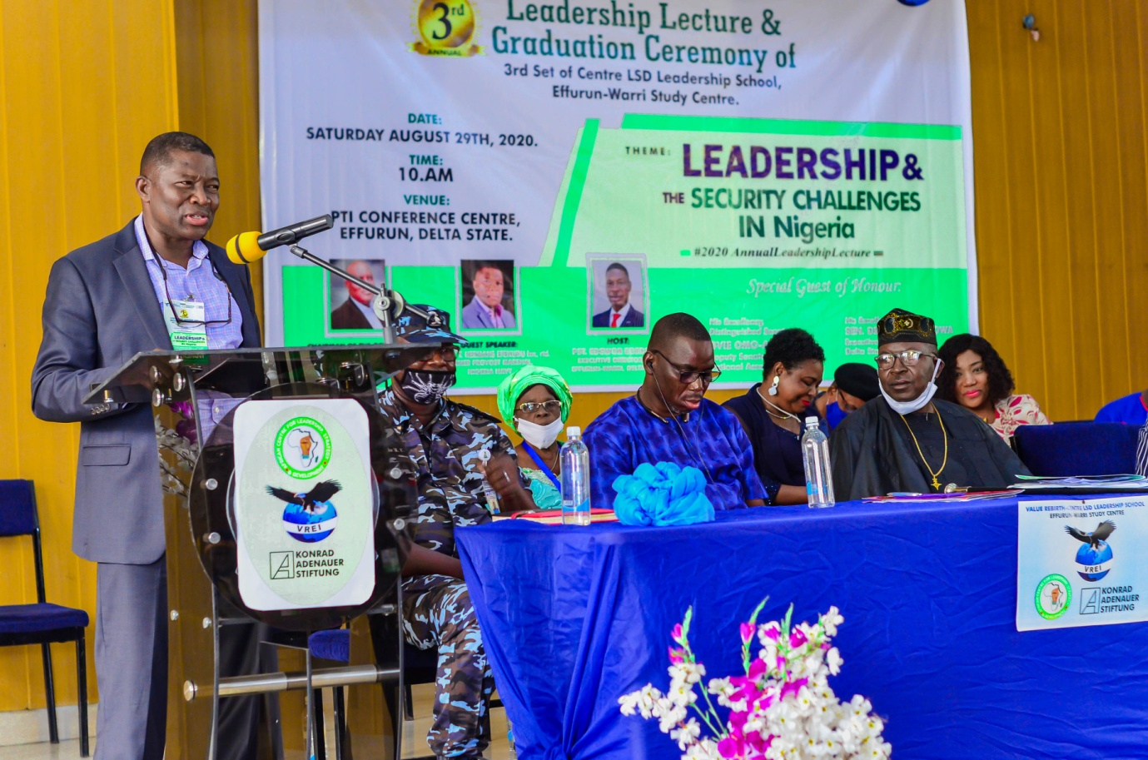The guest Lecturer: Leadership and security challenges in Nigeria by Navy Capt. Hermans Efenudu, fwc, rtd.
The leadership lecture with the theme: Leadership and the security challenge in Nigeria was delivered by Navy Capt. Hermans Efenudu, fwc, rtd. Former Provost Marshal, Nigeria Navy. In his introductory presentation, noted that, the quest for quality leadership and adequate security is the aspiration of citizens in most countries of the world. This is because the task of harnessing scarce resources in pursuit of human and national development is dependent on the quality and output of leadership. In the years passed, developments of nations have been by leaders who played vital roles in transforming their societies through good governance. Good leadership improves the quality of life of the citizens and emplaces adequate security and hence overall development of nations. He listed some leaders across the globe noting that, Africa on its own has produced some good leaders. Nelson Mandela of South Africa holds sway as one of the greatest figures of Black emancipation with his history of anti apartheid struggle. In Nigeria issues of good leadership have continued to be matters of concern since her independence in 1960. Despite the abundance of her human and natural resource, corruption and mismanagement of public wealth have hampered the development in the country and caused a lot of security challenges. The topic for this presentation is therefore quite apt considering our current challenges as a nation.
The lecture includes Leadership and Security Challenges. However while leadership can directly be conceptualized, Security challenges do not readily seem delineable. It is an end point. Therefore in examining security challenges, we shall look into other terms like Security as stand alone, National Security and Governance. The relationship between Leadership and good Governance will be examined.
According to the guest speaker, quoting leadership definition of Wikipedia, William E Rosebush and the US Army leadership manual, said their various leadership definition only highlighted skills, motivation and influence respectively but none tended to address the issue of values and different thought process. He noted that, Burns definition of leadership threw up values as propelling and rallying influence for sustainable motivation of followers while General Colin Luther Powel (a four star General) itemized leadership to include Trust, Clear Mission Statement, Selfless Service and Training. However, he defined Leadership as the act of influencing people through their common values and motivation to achieve the goodness of life for all.
Speaking on Security Challenges he noted that, Nigeria undoubtedly is one of the hotbeds of conflict presently in Africa. It has witnessed an unprecedented level of insecurity that now poses as threat to national security. In any civilized society, one of the primary responsibilities of Government is safe guarding of the welfare and security of the people. This is so because it is only Government that possesses the sole monopoly of the use of legal force to ensure safety and compliance to rules and regulations.
Our present security challenges include the following; Banditry, ritual killings, inter ethnic clashes, herdsmen/farmers clash, kidnapping, armed robbery, insurgency, corruption, etc. This scenario has become because of political instability, Youths despair, low job creation etc (John Nwodo). As he defined security as the state of being free from danger or threat including vulnerabilities, or a state of feeling safe while national security as defined by Michel (2009) does not consider economic activities as a prerequisite to ensure national security and Sarkesian (2010) does not consider the effect of the other elements such as unemployment, hunger, poverty, and environmental issues that drive insecurity. As he described their view are not adequate. Thus, he said, national security was initially conceived as protection against external military attacks, it is now widely understood to include other constituent elements such as; economic security, food security, cyber security, environmental security, energy security, minimization of crime, Housing security etc. noting that the absence of these elements constitutes threat to National Security. However, national security objective seeks the absence of threats to acquired values and subjectively the absence of fear that such values will be attacked (Arnold Wolfers, 1960). Whatever leads to threats of these valves will cause security challenges as individuals or groups will resort to protect its or their collective values or interest.
While addressing the issue of governance, he noted that, Governance is different from politics. Governance involves how government decision making affects people in that nation. Its role puts processes and structures used to direct and manage an organizations operations and activities. Furthermore, in the views of Doornbos, good governance implies “how a country is governed with respect to its procedure, transparency, quality and process of decision making amongst others. His emphasis is on the running of Government based on laid down procedure. Shehu shares his views and adds that good governance is predictable, open with enlightened policy making based not merely on theoretical construct but the fulfillment of a social contract between the leaders and the led (Eso). One sad aspect of the Nigeria nation is its pretext to run a federal system of Government when they are actually running a Unitary Government (John Nwodo; Presentation to the 8th National Assembly).
In his view to establish the relationship between leadership and good governance, he said, Leadership combines the available and material resources to deliver social, economic and welfare needs to the people. It is about making changes in the society that will positively affect the lives of the people. Similarly, good governance is an indicator of the extent to which the leadership is delivering public goods as stipulated in the governance pact. Such public goods include security, welfare and general well being of the people. Leadership at any level of Governance is driven by sound vision, honesty, integrity, accountability and probity. When this becomes good governance becomes possible. Its result will be effective service delivery to the people and also the support and loyalty of the led. Consequently, the attainment of good governance is a function of leadership; hence it is essentially Leadership reasonability. Thus there exist direct relationship between leadership and good governance.
He however, highlighted some causes of leadership and challenges in country, thus are; Institutional Framework, Public Service Delivery, Economic issues, Resource Management, Monoculture Economy, Corruption, Budget Implementation etc.
In conclusion noted, Nigeria is experiencing insecurity as a result of bad and irresponsible leadership which can be traced far back to 1960 and failed electoral system in the fourth republic where elections are manipulated by prospective political leaders. As he recommended that, for Nigeria to overcome its security challenges and become prosperous, it must ensure transparent good governance by its leaders. This is plausible when leaders are elected in a free and fair election and are accountable to the citizenry.
Discussion, comments and questions
The paper presented was further discussed by three discussants drawn from the graduating students including; Nkogbu Godfery, Atomatofa Rachel and Amioku Benjamin. Nkogbu Godfery emphasized on the need for citizens (leaders and followers) to use the Top Bottom approach and Bottom Top Approach in order brings inclusive and responsible leadership to bear in Nigeria and Government should provide security for her citizens as contained in 1999 constitution as amened. Atomatofa Rachel on her views aligns with Nkogbu Godfrey on the need for government to fulfill their constitutional obligation of securing lives and properties of her citizens and encourage others to be involve in peaceful securing their lives and properties. Amioku Benjamin also discussing the paper added that, there is leadership vacuum in our society and those occupying leadership position should attend leadership lectures and training, practices same with best practice.
There were also questions and comments by the participants for which answers were provided by the Resource persons and other dignitaries on the high table.
Valedictory Speech by the Class Governor of Set 2
Chief Victor Okiri, Set 3, Governor, Value Rebirth-Centre LSD Leadership School, Effurun-Warri Study Centre who was represented by His Deputy, in his valedictory speech, appreciated the management and staff of the Effurun-Warri Study Centre for the knowledge impacted on the graduating students and expressing his profound gratitude to God Almighty for seeing them through the one year plus leadership training without any mishappening but with mind blowing testimonies among others. In his words stated “We actually came, we saw and we conquered” as he urge graduating students to be good ambassador of the centre by applying the knowledge acquired in positive way as he finally, encouraged the matriculating students to be open minded to learn, unlearn and relearn and assure them of the best of time ahead.
Testimonies of Graduands
Several students shared their testimonies saying that; the leadership school has helped them in diverse ways, especially in people, process and time management, self-encouragement, motivation and improved public relation, moral and behavioral changes among others.
Give Back
The graduating students of the set 3, appreciated faculty and administrative members of the Effurun-Warri Study Centre with gift items and they presented camera for the centre for videoing and snapping of pictures during further lectures.
Presentation of Certificate and award of Excellence
Certificates were presented to 69 students who met the prerequisite for certificate collection from the centre out of the 78 students who graduated from the 3rd set. There was also special recognition and award of gift to some deserving graduands. The categories of recognition and awards were in the following order;
- Most Punctual Student
Asadarho Vwaire Laurenta & Akinyemi Majekodunmi O.
- Most Compliant Student with Assignment Submission
Okekporo Victor E.
- Best Behaviour Graduating Student
Atomatofa Rachel & Matthew Osharekure
- Most Distance Graduating Student (From Lagos)
Osuji D. Chika
- Most Participative Graduating Student
Nkogbu O. Godfrey & Idonor E. Justice
- Selfless Leadership Recognition
Iyereoretin O. Charles
- Special Leadership Recognition
Ericson Egbaivwie
- Best Performing Exco
Dudusola Dele
- Best Graduating Student
Uyeri AjiriOghene
- Set 3, Centre LSD Ambassador
Christian Eshenake
Another category of award was the Award of Excellence. The recipients of the 2020 awards was;
- Maxwell O. S Ogedegebe (Esq.), Director General, Conference for the Actualization of Human Right, in recognition of His Selfless service to humanity.
Inauguration of Alumni
The Value Rebirth-Centre LSD Leadership School, Effurun-Warri Study Centre Alumni was inaugurated along the Excos by the Centre LSD Abuja, Alunmi President Mr. Alaba Adekunle. Mrs. Crossdale Josephine, Alunmi President, Effurun-Warri Study Centre gave her acceptance speech as she express that the exco under her leadership is committed to moving the school forward within their ability.
Matriculation Oath Taking
The newly admitted set 4 students of the Value Rebirth-Centre LSD Leadership School took their Matriculation Oath before Mr. Obot Obot and all other guests present at the ceremony. After the oath taking, they were made to sign and submit their respective Matriculation Oath.
Media Coverage
The 3nd annual Leadership lecture/graduation ceremony had a massive coverage by the media including: Galazy TV, Kpoko and Crown FM (100.5 & 89.9) respectively, Daily Post, Independent Television, The Urhobo Voice Newspaper, Business Day Newspaper, News Agency of Nigeria, Leadership Newspaper, Tribune, and a designated still picture photographer. Below are some of the news links;
- http://advocate.ng/2020/09/value-rebirth-centre-lsd-leadership-school-effurun-warri-study-centre-graduates-3rd-sets/
- https://tribuneonlineng.com/embrace-community-policing-hold-your-leaders-responsible-omo-agege-charges-nigerians
- https://realtime.ng/2020/08/30/omo-agege-experts-dry-dearth-of-quality-leadership-in-nigeria
- https://reformeronline.com/omo-agege-decries-dearth-of-quality-leadership-in-nigeria
- https://leadership.ng/2020/08/31/cleric-calls-for-leadership-training-to-address-developmental-challenges/?amp=1
- https://newsdiaryonline.com.cleric-calls-for-leadership-training-to-address-developmental-challenges/amp/
- https://nnn.ng/cleric-calls-for-leadership-training-to-address-developmental-challenges/

Participation
Over 100 persons attended the 3rd Annual Lecture/Graduation Ceremony of the 4th set of Student of the Leadership School as we observe maximum compliance with covid-19 protocols.
Challenges
Some challenges encountered include;
- The intake of students is by far less than the total number of applicants; the centre will want a situation where a good number will be admitted into the school.
Recommendation
Based on the challenge stated above, we recommend the following:
- The centre will welcome increased funding in order for it to rent a bigger hall that will contain a higher number of students. This way, the school can admit more students.
Conclusion
The Leadership school is fast gaining ground in the Niger-Delta region with students drawn from different states of the region. The commitment to support the course by Konrad Adanauer Stiftung, is a big boost and a mark of commitment to addressing the leadership challenge in Africa and Nigeria in particular. We thank the African Centre for Leadership, Strategy and Development (Centre LSD) for this wonderful partnership and we also appreciate Konrad Adenauer Stiftung (KAS) for standing by us and opening their doors wide to us anytime we knock. We like to state that the views canvassed in this year’s lecture will certainly help to shape the issues of security of lives and property, and thereby reduce insecurity in the country.

