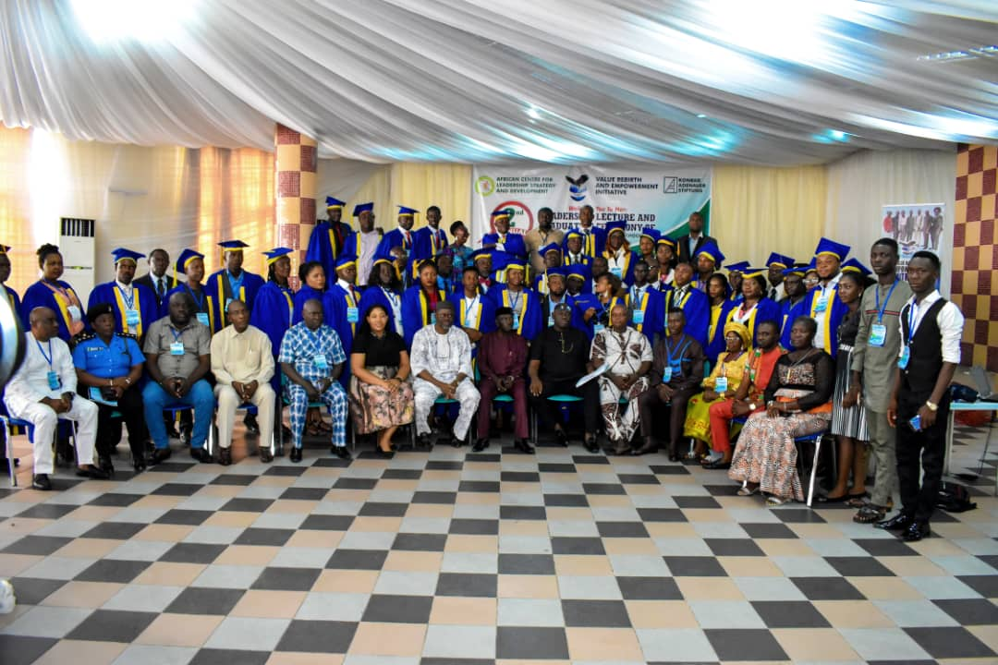
REPORT OF VALUE REBIRTH AND EMPOWERMENT INITIATIVE (VREI) IN PARTNERSHIP WITH THE AFRICAN CENTRE FOR LEADERSHIP, STRATEGY AND DEVELOPMENT (CENTRE LSD) ON THE 2ND ANNUAL LEADERSHIP LECTURE/GRADUATION CEREMONY OF THE 2ND SET OF LEADERSHIP SCHOOL, EFFURUN-WARRI STUDY CENTRE WITH SUPPORT FROM KONRAD ADENAUER STIFTUNG (KAS) HELD MAY 11TH, 2019 AT WELLINGTON HOTEL, EFFURUN, DELTA STATE.

Executive summary
The 2nd Annual Leadership Lecture and graduation of the 2nd Set of students of the Centre LSD in partnership with VREI Leadership School cum the matriculation of the 3rd set of students held 11th May 2019 at wellington hotel, Effurun, Delta state. This year’s annual lecture themed “Leadership and the Youth Question in Niger Delta’’, was carefully chosen owing to the urgent need for the country to raise transformative leaders/followers that will convert the rich resources of the land to wealth and take the region to a level that is at par with her contemporaries. It is to raise leaders and develop quality leadership skills that will enable diversification as the way forward for the economy, that Value Rebirth and Empowerment Initiative (VREI) in partnership with the African Centre for Leadership, Strategy and Development (Centre LSD) with support from Konrad Adenauer Stiftung (KAS), a German political Foundation put the lecture together.
The Executive Director of VREI and Director of Studies at the Effurun-Warri Study Centre of the Leadership School, Pst. Edewor Egedegbe in his welcome address informed the gathering that a total of 53 students out of over 83 admitted will be graduating in the 2nd set and when added, Effurun-Warri Study Centre would have graduated 104 students since inception.
The Founding Executive Director of the African Centre for Leadership, Strategy and Development (Centre LSD), Dr. Otive Igbuzor in his remark said the idea of starting the leadership school was borne out of the realization that leadership is a major problem especially in Africa. He pointed out that many scholars and commentators are in agreement that leadership failure is one of the major factors responsible for the underdevelopment of Africa. He said however, it has been proven that leaders can be trained which is why the Centre LSD Leadership Abuja is designed for people who want to become leaders and be equipped with leadership skills for transformations of organizations and society.
The chairman of the occasion, Prof. Tony Akpoborie, a Professor of Hydrology, in his opening remark, commended the efforts of the school for grooming leaders, and urged the graduating students to participate in the political process, saying that if they don't participate in the process then they will be ruled by the village idiots. He noted that if the leaders of the past have failed, the present youth of our nation should not fail.
Goodwill messages were delivered by the following persons; Mr. Monday Osasah Ag. ED, (Centre LSD) Abuja, Hon. Ramson Onoyake (Executive Chairman, Uvwie LGA) represented by Hon. Henry Biyibi, Pst. Emmanuel Nwanchukwu (Resident Pastor, LFC Uti), Pastor Eniola Akintan (founder, Kings Fisher Church, Ibadan), Hon. Comr. Reuben Izeze (Member Rep. Ughelli South Constituency, DTHA) represented by Engr. Anderson Ejovi, Mr. Voke Ighorodje (CSO Representative), Amb. Dr. (Mrs.) Onyi Ikemefuna, United Nations Representative and Faculty member.
The leadership lecture with the theme: Leadership and the Youth Question in the Niger-Delta was delivered by Prof. Benjamin Okaba, Dean of Faculty of Humanity and Social Sciences, Federal University Otuoke, Bayelsa State. The lecture focused on the following;
- Who is considered a youth and the common characteristics of a youth
- Leaders and Leadership; kinds, levels and qualities
- The Youth question; challenges and possible solutions of youth development in the Niger Delta.
The paper was discussed by three discussants drawn from the graduating students. The governor of the 2nd set of the Effurun-Warri study centre of the Centre LSD Leadership School, in his valedictory speech appreciated all those present at the ceremony and encouraged the graduating students to be true leaders wherever they find themselves. Graduands gave testimonies of how the Leadership School imparted them and certificates were presented to those who met all requirements for collection of certificates. Awards were given to deserving graduating students and award of excellence were also given to some deserving dignitaries.
The newly admitted students of the 3rd set took their Matriculation Oath before the Administrative Secretary of the School, Mr Obot Obot. The ceremony was witnessed by some set 1 students of the Leadership School.
To ensure application of the lessons of the theme from participants, group work was given “What to be done to change the negative narrative of the Niger Delta youths” And was followed by presentation by the respective groups.
The 2nd annual leadership lecture/graduation ceremony had a massive coverage by the media, and 320 persons attended the ceremony.

Preamble
The 2nd Annual Leadership Lecture and graduation of the 2nd set of students of the Centre LSD in partnership with VREI Leadership School cum the matriculation of the 3rd set of students held 11th May 2019 at Wellington Hotel, Effurun, Delta State. The idea of the Effurun-Warri Leadership School was set up to train leaders by attempting to unravel the complexity of leadership and offering a framework that will help people to become great leaders. This year’s annual lecture themed “Leadership and the Youth Question in the Niger-Delta”, was carefully chosen owing to the urgent need for the country to raise transformative leaders/followers that will convert the rich resources of the land to wealth and take the Niger-Delta region to a level that is at par with her contemporaries. The region is crawling on the ground today because of absence of quality leadership and followership, this is not because the people are inferior to pose leadership and effective followership traits, but due to lack of visionary leadership and unprepared youth not ready to take over the leadership of their generation. With successive government now insisting on diversification as the way forward for the economy and over 70% of youths in the Niger-Delta that remain unskilled which makes them unemployable, it becomes imperative that leaders are raised among the youths, which is why the African Centre for Leadership, Strategy and Development (Centre LSD) in partnership with Value Rebirth and Empowerment Initiative (VREI) with support from Konrad Adenauer Stiftung (KAS), a German political Foundation put the lecture together.
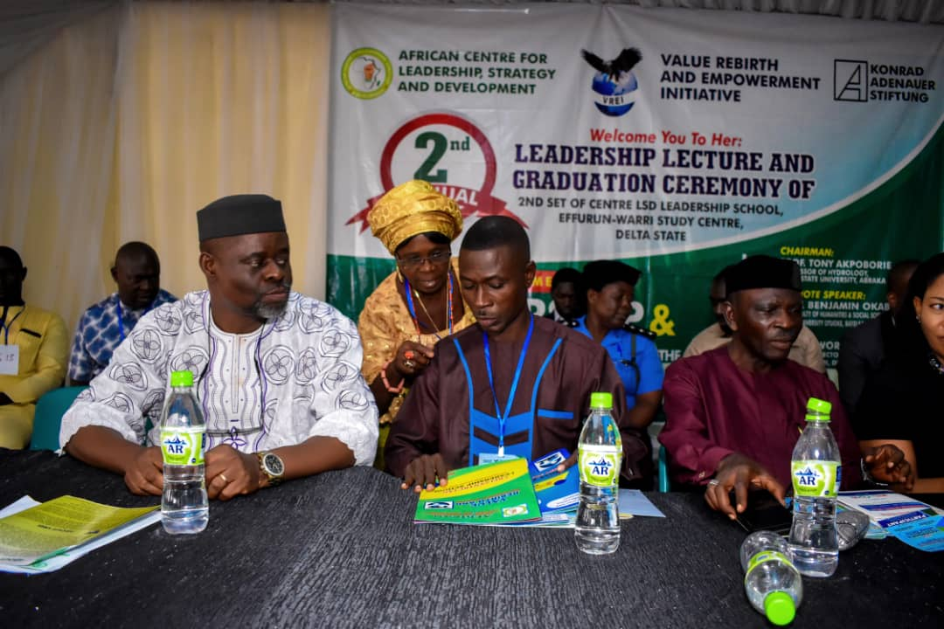

Welcome Address by Executive Director, VREI
The Executive Director of VREI and Director of Studies for the Leadership School, Pst. Edewor Egedegbe in his welcome address gave a brief account of how the Leadership School, Effurun-Warri Study Centre started in June, 2017 as the first of its kind in the South-South (Niger-Delta), in a bid to train leaders by attempting to unravel the complexity of leadership and offering a frame work that will help people with focus on leader development and leadership development. The Director of Studies shared his organization’s (VREI) vision, mission, value and pointed out that since inception, Value Rebirth and Empowerment Initiative have been committed to its thematic focus in Peace Building, Civic Education, Governance and Environment and have intervened in several governance and peace related issues such as election observation, leadership training, conflict mitigation/peace building, tax justice platform, gender based violence eradication, community leadership enhancement among others. He also informed the gathering that the Leadership School which is free runs for a year holds its graduation/matriculation ceremony every May, 53 out of the 83 students admitted will be graduating in the 2nd set and when added, Effurun-Warri study centre would have graduated 104 students since inception. He made it known that for the next leadership academic session, over 100 applications have been received and 83 persons have been shortlisted for admission.
The Director of studies took advantage of the welcome remark to share his experience as a student of the Leadership School for 2012/2013 academic session. He said his quest for knowledge and also to be a solution to the multifaceted leadership challenges across Africa, Nigeria and in particular the Niger-Delta which occupies 7.5% of the total land area of Nigeria, 70,000km², and is home to approximately 30million people was a major impetus for his interest and subsequent training at the Centre LSD Leadership School, Abuja, where he was trained free of charge with others from different States across the federation for one year. He said he travelled to Abuja every third Saturday to acquire this much needed leadership knowledge, the mother of all knowledge because, the success and failure of any system be it spiritual or physical depends largely on leadership and painstakingly, he followed every lecture that was presented with passion, and contacted so much grace and insight each month he attended. The Leadership School training and the inspiration from the Holy Spirit gave rise to the establishment of his organization, Value Rebirth and Empowerment Initiative.
In addition, Pst. Edewor Egedegbe informed the audience that as part of the requirements for graduation, students were grouped to carry out Community Development Service (CDS) and they delivered life transforming projects during the session as indicated below;
Group 1: Reaching out to the needy: Presentation of food items to an orphanage home (Eagle Hand Foundation), in Warri, Delta State.
Group 2: Giving back to the less privileged: presentation of food items and relieve materials to Heart of Delta’s children’s home, Effurun, Delta State.
Group 3: Showing love/care: presentation of food items to Nigerian Prison Service, Okere road, Warri, Delta State.
Group 4: Leadership Campaign: A one day leadership summit on THE POWER OF IDEA AND THE NEED FOR VALUE/MORAL RE-ORIENTATION at Delta State Polytechnic, Otefe-Oghara, Delta State.
Group 5: Hospital Outreach: Presentation of relieve materials to Ekpan general hospital, Effurun, Delta State.
Gropu 6: Donation to those in need: presentation of relieve materials to Saint Anne’s orphanage home, Effurun, Delta State.
Group 7: Behavioral change: A one day sensitization workshop on Gender Based Violence (GBV) through visual media at Ugbolokposo Secondary School, Effurun, Delta State.
He appreciated the African centre for Leadership, Strategy and Development for their support and also the graduating students for their benevolence towards the school as a quick response to the impact of the program on their lives, and mentioned some of their contributions to the centre which include but not limited to;
- Through the effort of the class executive led by the governor, they took care of their lunch up to 75%
- They felt the director of study was spending so much in the area of training hall and they decided to pay one year rent for a new hall where set 3 will begin their lecture from June 8, 2019
- Procurement of 50 chairs for the leadership school training centre. etc.
Finally, he appreciated two other categories of people for their contribution toward the continued success of Effurun-Warri study centre. They include; the faculty members (who offered selfless service without being paid), staff of VREI for their immense contributions.
Remark by the Founding Director, Centre LSD- Dr. Otive Igbuzor.
The Founding Director of the African Centre for Leadership, Strategy and Development (Centre LSD), Dr. Otive Igbuzor, in his remark said the idea of starting the leadership school was borne out of the realization that leadership is a major problem especially in Africa. He pointed out that many scholars and commentators are in agreement that leadership failure is one of the major factors responsible for the underdevelopment of Africa. He said however, it has been proven that leaders can be trained which is why the Centre LSD is designed for people who want to become leaders and be equipped with leadership skills for transformations of organizations and society. The school he said provides students with tools and ways to have vision for leadership and become better leaders. At the national level, the school has graduated 681 students and in Delta State, at the end of the graduation ceremony, the school would have graduated 104 students, 51 in the 1st set and 53 in the second set. He also used the opportunity to congratulate the 83 students taking their matriculation oath.
He described the choice of the theme: Leadership and the Youth Question in the Niger-Delta for the graduation ceremony as very apt. He went further to say although the challenge of leadership is a global one, the problem is very serious in the Niger Delta, as it appears that the leaders from the region get their legitimacy from outside the region, they are therefore not responsible and accountable to the region. He said the Niger Delta youth have been neglected and excluded from development and political process, there is therefore the need to build a new crop of leadership that will focus not only on youth development but transformation of the entire Niger Delta region. He stated that he’s looking forward to a time that graduates from the leadership school will dominate the political leadership landscape in the Niger Delta and bring about the transformative leadership that is badly needed.
He concluded by appreciating the management and staff of Value Rebirth and Empowerment Initiative (VREI), past students of the leadership school in Delta State, the graduating students, matriculating students, the lecturers and KAS for their support in making the graduation ceremony a success. He specially appreciated the Chairman of Air Peace Airline, Barr. Allen Onyema who has offered automatic employment to two graduating students to join the cabin crew of the airline.
Chairman’s opening Remark
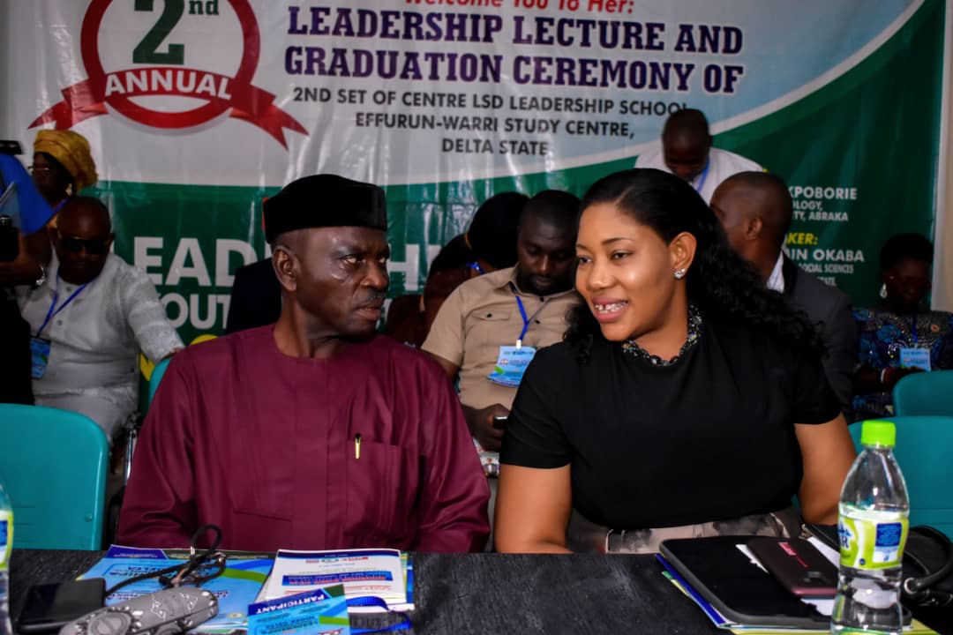
The chairman of the occasion, Prof. Tony Akpoborie, a professor of Hydrology, in his opening remark, commended the efforts of the school for grooming leaders, and urged the graduating students to participate in political processes, saying that if they don't participate in the process, then they will be ruled by the village idiots. He noted that if the leaders of the past have failed, the present youths of our nation should not fail.

He opined that the leadership problem of the country and Africa can be traced back to our leaders who sold us into slavery which took place for 350 years. The resultant income/benefit of the sale could not be used for any form of development. Stressing that leadership problem started from our fore fathers who were into slavery business.
He added that, before now he has been so grieved with the nature of happening in our beloved country and that the good news is that his worries of a better society and nation as a whole is beginning to come to an end with initiatives like this and promised to always contribute his quota to have a better nation.
He concluded by saying that he will discuss with his Dean of faculty who is also present in the ceremony to see how Delta State University, Abraka can partner with the leadership school and by so doing promote the school.

Goodwill Messages
Goodwill messages were delivered by the following at the event; Mr. Monday Osasah Ag. ED, (Centre LSD) Abuja, Hon. Ramson Onoyake (Executive Chairman, Uvwie LGA) represented by Hon. Henry Biyibi, Pst. Emmanuel Nwanchukwu (Resident Pastor, LFC Uti), Pastor Eniola Akintan (Founder, Kings Fisher Church, Ibadan), Hon. Comr. Reuben Izeze (Member Rep. Ughelli South Constituency, DTHA) represented by Engr. Anderson Ejovi, Mr. Voke Ighorodje (CSO Representative), Amb. Dr. (Mrs.) Onyi Ikemefula, United Nations Representative and Faculty member.
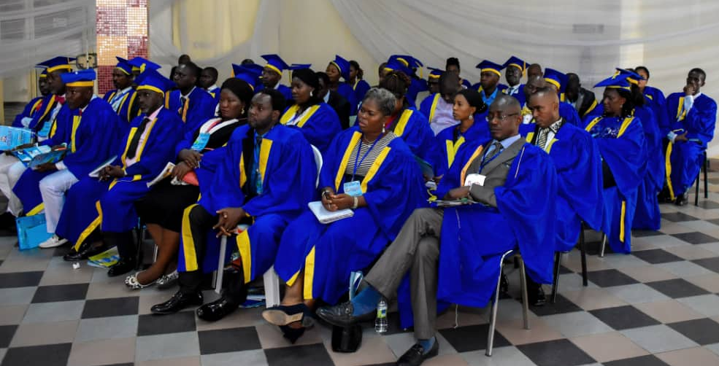
In their respective goodwill messages, they encouraged the graduating students to put to good use everything they have learnt from the Leadership School in the course of their training. Mr. Monday Osassah, in his goodwill message, enjoined the graduating students to use the knowledge they have acquired to build a better society, and also urged the new students to be serious with the school and put other social activities aside to be in attendance in every lecture, The Executive Chairman, Uvwie LGA, Hon. Ramson Onoyake represented by Hon. Henry Biyibi, stated that lack of training is the cause of bad Leadership in Nigeria, and that it is very important for political office holders to go through Leadership School so as to be equipped with the relevant skills that will help them to function maximally, the Resident Pastor, LFC Uti, Pst. Emmanuel Nwachukwu, noted that poor Leadership has ruled our Africa continent for so long, and that there is hope through the training of leaders by the leadership school, and commended the great work of the Centre, Pst. Eniola Akintan, Founder, Kings Fisher Church, Ibadan, stressed that there is no school of learning that will conform capacity on someone, and that it is what one does with the knowledge acquired that will determine his placement tomorrow in life, Member Representing Ughelli South Constituency, DTHA, Hon. Comr. Reuben Izeze Represented by Engr. Anderson Ejovi, urged the graduating students to get involved in the electoral process in the state, and commended Centre LSD Leadership for the good work, Civil Society Representative, Mr. Voke Ighorodje also enjoined the graduating students to use the knowledge they have gained from the school to make a positive change as ambassadors wherever they go or find themselves, United Nations Representative, Amb. Dr. (Mrs) Onyi Ikemefuna, affirmed that learning is timeless, and urged the graduating students to begin to live the knowledge they have acquired, else what they have acquired will be meaningless. She stated that she will continue to stand by the school.
The Lecture: Leadership and the Youth Question in the Niger-Delta - Prof. Benjamin Okaba
The leadership lecture with the theme: Leadership and the Youth Question in the Niger-Delta was delivered by Prof. Benjamin Okaba, Dean of Faculty of Humanity and Social Sciences, Federal University, Otuoke, Bayelsa State. He described the theme of this year’s lecture as germane to the current discourse on the emergent phenomenon of global youth unrest, youth criminality and the desire all over the world to change this negative trend and narrative. According to him, about 67 million young people between the ages of 15 and 24 are actively searching for work but are unable to find one. This situation he said is worst in the rich Niger Delta where the experience of the paradox of poverty in the midst of abundant human and natural resources has translated the region into the exploited, devastated, devalued, criminalized and therefore unsafe environment for business and development. The lecture focused on the following:
- Who is considered a youth and the common characteristics of a youth
- Leaders and Leadership; kinds, levels and qualities
- The Youth question; challenges and possible solutions of youth development in the Niger Delta.
According to the guest speaker, leadership is a process by which a person influences others to accomplish theirs or an organizational objective and directs the organization in a way that makes it more cohesive or coherent. He highlighted six qualities of a leader as follow;
L- Loyal to the cause, Long suffering, Listener, Learner etc
E- Educated about contemporary issues
A-Able to organize
D-Dedicated to the mission
E-Empowered by their acceptance and support
R- Responsible for the activities involved with their role.
Other qualities of a successful leader he mentioned include; integrity, courage, ability to care, creativity, flexibility, firmness etc.
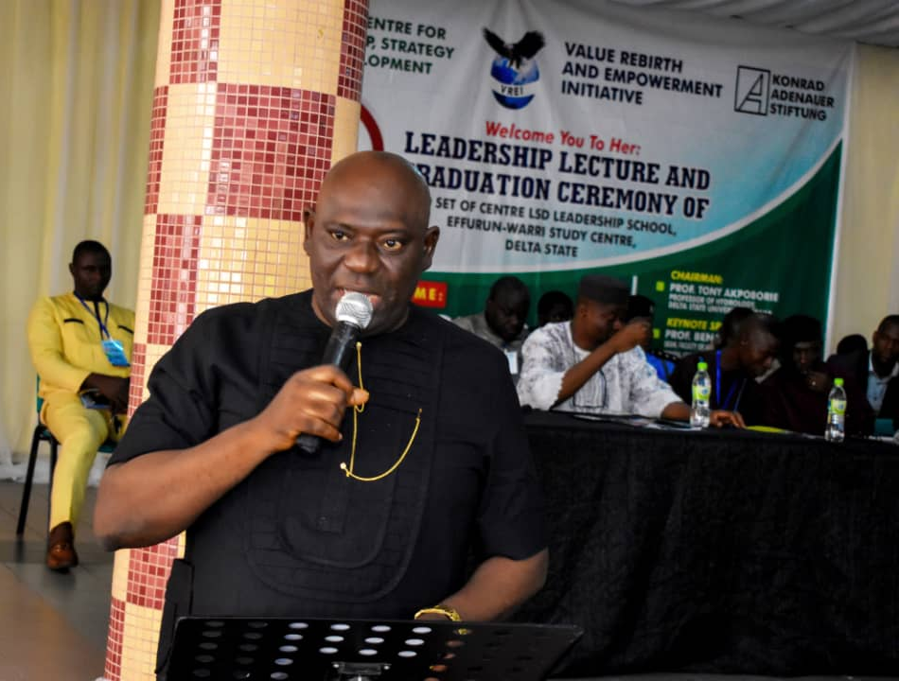
The Youth Question in the Niger-Delta he said is one of access to opportunities for livelihood and leadership development. He also noted that the people of Niger-Delta have depended on the government and multinational oil companies for these opportunities, however forgetting the third force which is they themselves.
He went further to point out some problems of youth development in Nigeria and the Niger-Delta particularly as; corruption, unemployment, poverty, poor influence from social media, poor quality of education, dependability, adapting bad lifestyle, lack of self-respect and ability to succeed, poor reading culture, inappropriate allocation of funds etc.
Some possible solutions he gave to the problems listed above are; youth employment, entrepreneurial programmes, even distribution of national wealth, engaging youths in sports, developing a more productive educational system, self discipline, cultivation of right attitude to work, service and humanity etc.
Conclusively, he said that Leadership in the Niger-Delta cannot be effective except when backed by a vocal followership with the capacity to demand accountability especially in the light of many promises. He also stressed that youth development is a guarantee to a safe and prosperous society today and tomorrow for all and sundry.
Discussion, comments and questions
The paper presented was further discussed by three discussants drawn from the graduating students including; Ighovogho E. Oghenemudia, Ovie Adarighoufa Faith and Tayo Ese Miriam. Ovie A. Faith emphasized on the need to redefine age bracket in Africa, arguing that the current age bracket as defined by the African Charter is limiting youth’s performance in Africa. Ighovogho E. Oghenemudia on his view noted the causes of the youth question and also suggested the likely possible solutions which includes; mindset rebirth, moral rebirth, good representation at all levels among others. While Tayo Ese Miriam also discussing the paper added that, our school system is robbing our youth of real education and the failures of home to instill the true values of hand work has entrenched materialism in society as such get-rich quick syndrome that is eating up our teeming youth population.
There were also questions and comments by the participants for which answers were provided by the Resource persons and other dignitaries on the high table.
Valedictory Speech by the Class Governor of Set 2
Eyela C. Emmanuel, the governor of the 2nd set of the Effurun-Warri Study Centre of the Centre LSD Leadership school, in his valedictory speech urged the graduating and matriculating students to be good Ambassadors of the VREI-Centre LSD Leadership School by changing the narratives of bad leadership to good narratives anywhere they find themselves, not by forcing people but by influencing people by the way they lead others. Also with deference celebrating the founding ED, Centre LSD and the ED, VREI for taking this wonderful step in the reorientation of human capital as a way of correcting the present and future of our great nation. He also encouraged the matriculating students to take this opportunity very serious, assuring them they will not regret being part of the School.
Testimonies of Graduands
Four graduating students shared their testimonies saying that; the leadership school has helped them in diverse ways, especially in people and process management, time management, boldness to speak in public place and also influence others to achieve goals.
Presentation of Certificate and award of Excellence
Certificates were presented to 33 students who met the prerequisite for certificate collection from the centre out of the 53 students who graduated from the 2nd set. There was also recognition and award of gift to some deserving graduands. The categories of recognition and awards were in the following order;
- Most Punctual Student
Ferdinand N. Ezeugo
- Most Compliant Student with Assignment Submission
Arigbe Israel
- Most Decent Graduating Student
Erica B. Oddiah
- Most Innovative Graduating Student
Ekpiteta J. Maccellinus
- Most Distant Graduating Student
John Bede C. Obasi
- Set 2, Centre LSD Ambassador
Ighovogho E, Oghenemudia
- Best Graduating Student
Oke-oghene O. Alex
- Special Leadership Award
Eyela C. Emmanuel
- Most Participative Student
Tayo Ese Miriam
Another category of award was the leadership champion award. The recipients of the 2019 awards were;
- Hon. Peter Mrakpor (Esq.), the Attorney General/Hon. Commissioner for Justice, Delta State, in recognition of His humility and effective service to humanity.
- Hon. Ramson Onoyake (Executive Chairman, Uvwie LGA) in recognition of His effective leadership and people management.
Matriculation Oath Taking
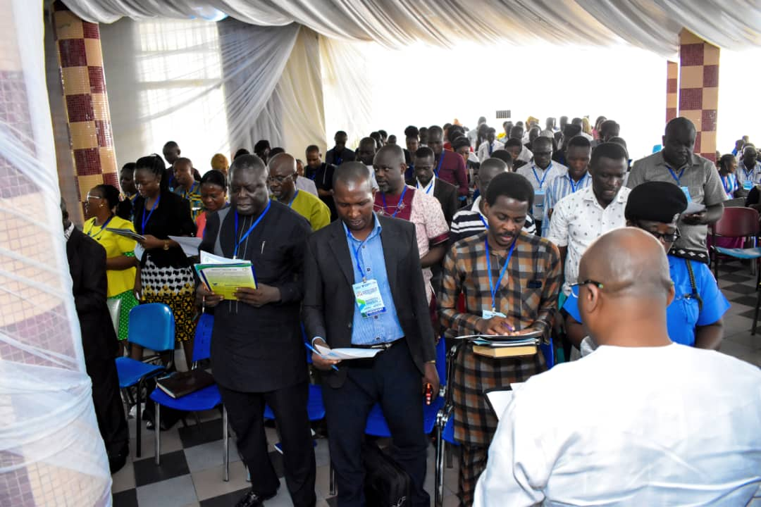
The newly admitted students for the 3rd set of the VREI-Centre LSD took their Matriculation Oath before Mr. Obot Obot and all other guests present at the ceremony. After the oath taking, they were made to sign and submit their respective Matriculation Oath.

Group Work Presentation
To ensure the application of the lessons of the theme of the lecture from participants, group work was given. Participants were divided into four Groups to brainstorm and answer the group question. The question for the group work was on “What to be done to change the negative narrative of the Niger Delta youth” with a positive one- The following were some of the recommendations going forward.
Group one
- Our leaders should make deliberate effort to be trained and retrained to enable them perform better. The Youths should be taught leadership skills early enough.
- Poverty alleviation program should be put in place.
Group two
- . The government should provide entrepreneurship program as a major part of the curriculum and create more industries for youth employment.
- The leaders should make deliberate effort to see that our Youths are empowered and meaningfully engaged.
- An enabling environment for innovation and invention to thrive. Government should also create space for the youth in active politics.
Group three
- Advocacy for even distribution and proper utilization of our resources and Leaders should be held accountable for the judicious management of resources.
- Government agencies in charge of youth development should listen to their plight, generate and implement solutions in regards to youth issues.
Group four
- The government should pay continuous close attention to our education system in all ramifications and reading culture should be enshrined in our school system.
- Value re-orientation for the youths is key to development.
- The Government should establish an agency for talent development.
Media Coverage
The 2nd annual Leadership lecture/graduation ceremony had a massive coverage by the media including: Delta Broadcasting Service, Daily Post, Independent Television, The Urhobo voice Newspaper, Business Day Newspaper, News Agency of Nigeria and a designated still picture photographer. Below are some of the news links;
- http://www.thetidenewsonline.com/2019/05/13/foundation-tasks-ndelta-youth-on-leadership/
- https://www.pmnewsnigeria.com/2019/05/12/foundation-tasks-n-delta-youths-on-leadership/
- https://dailytimes.ng/foundation-tasks-n-delta-youth-on-leadership/
Participation
320 persons attended the 2nd Annual Lecture/Graduation Ceremony of the 2nd set of Student of the Leadership School. The details of this can be found on the participants’ list.
Challenges
Some challenges encountered include;
- The intake of students is by far less than the total number of applicants; the centre will want a situation where a good number will be admitted into the school.
Recommendation
Based on the challenge stated above, we recommend the following:
- The centre will welcome increased funding in order for it to rent a bigger hall that will contain a higher number of students. This way, the school can admit more students.
Conclusion
The Leadership school is fast gaining ground in the Niger-Delta region with students drawn from different states of the region. The commitment to support the course by Konrad Adanauer Stiftung, is a big boost and a mark of commitment to addressing the leadership challenge in Africa and Nigeria in particular. We thank the African Centre for Leadership, Strategy and Development (Centre LSD) for this wonderful partnership and we also appreciate Konrad Adenauer Stiftung (KAS) for standing by us and opening their doors wide to us anytime we knock. We like to state that the views canvassed in this year’s lecture will certainly bring about the right attitude of the youths towards leadership in the Niger-Delta. We also use this opportunity to appreciate Air Peace Airlines Chairmam/CEO, Barr. Allen Onyema for his commitment to provide jobs for two graduands of the Effurun-Warri study centre, the gesture is no doubt reassuring and has upped our enthusiasm and commitment to the Nigerian project.

